Guidelines for R2 Interview:
1) R2 questions should be more practical instead of theoretical.
2) Candidate should have good understanding of React, Redux or Mobx, Javascript/Typescript and CSS.
3) Candidate should have good analytical skills in terms of breaking down problems into smaller pieces.
4) Should know how to maintain code quality in terms of readability, reusability, performance, Testability, Maintainability.
5) Should be eager or passionate to learn new skills or advance current skills.
6) Should have fair enough communication skills, so that they can conduct small meetings and discussions in Organization.
Some of the questions around above guidelines:
Q: Where do you write business logic in react/redux application?
Answer: It can spread to components, selectors and reducers. We should avoid writing business logic in reducers though. Its better to keep it in selectors as you can memorize it.
Q: How to detech browser compatibility issues before using css or js new features.?
Q1. For any level.
Walk me through git flow. If you have code you want to get pushed up how would you do that?
Q2. For 3+ years experience:
We can ask for estimates here to build this component.
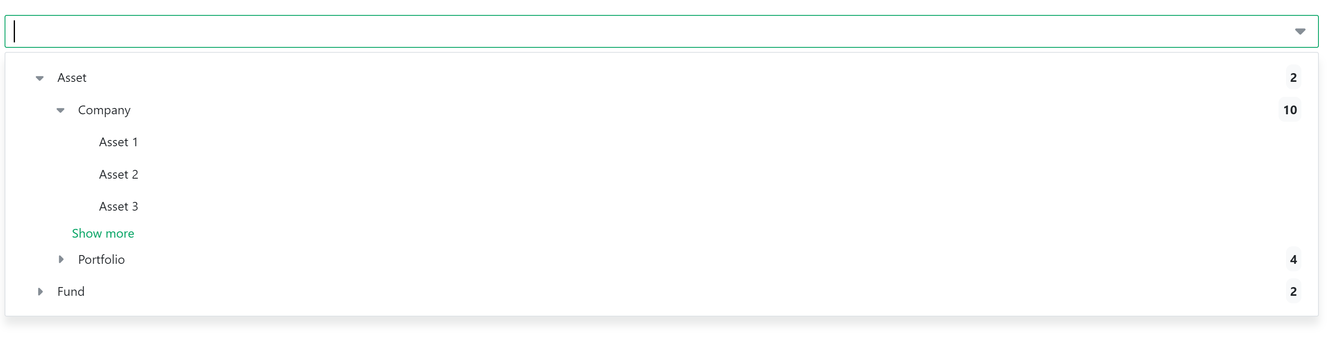
Give candidate 5mins to think.. There is no right answer to this.. this question is asked to understand thinking process of candidate.
1) Candidate should split this component into 3-5 smaller components.. for example: 1) search input/dropdown 2) tree 3) tree-option 4) showMore 5) badge icon with number
2) Candidate should ask right questions like 1) what showmore does, 2) how search should work? 3) How many levels of tree
3) Any Estimation between 5-20 days is fine depending on what features are decided to be implemented, but it is definitely not 1-2 days of work.
Q3. For All Levels
let tech = [
{ id: 1, name: "Frontend", value: "HTML" },
{ id: 2, name: "Frontend", value: "React" },
{ id: 3, name: "Backend", value: "Node" },
{ id: 4, name: "Backend", value: "PHP" },
{ id: 5, name: "Backend", value: "Java" },
];
Question: Write a function Named groupyBy, it should groupBy using name property.
o/p {
Frontend: [{}. {}],
Backend: [{}, {}, {}]
}
Answer: tech.reduce((acc, curr) => {
if(!acc[curr. groupName])
acc[curr. groupName] = [curr]
else
acc[curr. groupName] = acc[curr. groupName].concat(curr)
return acc;
}, {}); Candidate can also use single for-loop to achieve this, that solution is also fine, its just that complexity of solution should be O(n)
o/p {
Frontend: [{}. {}],
Backend: [{}, {}]
}
Q4. For All Levels:
function someFun(datastructure) {
let name1 = datastructure.find(({ id }) => id==123).name;
let name2 = datastructure.find(({ id }) => id==3).name;
let name3 = datastructure.find(({ id }) => id==987).name;
return name1 + name2 + name3;
}
What can we change in this function such that complexity can be reduced to O(1)??
Answer: datastructure change it to object or SET and remove find function and use key to find objects inside the datastructure.

Q5. Any Level: Why do we use re-select library or do we need caching in redux application?
Answer: To memorize selector results.
Q6. More than 3+ years experience
How do we deploy our react application to prod?
Answer: we bundle our application using a bundler, that bundle is kept on a application server and served to clients. Candidate should be able to explain complete process including CI/CD, AWS at high level.
Q7. 3+ Years, How can store the state in react component without re-rendering the component?
Answer: using refs.
Q8. Any Level: Where should we keep state of the form in react/redux applications?
Answer: State must be kept in local. Because forms data is not a shared object.
Q9: 3+ Years. What should be kept in redux state and what should be avoided?
Answer: Derived data must not be kept in redux store, form data should not be stored in redux unless form data is shared with other control or form in app
Q10. 8+ years experience, How can we make sure to have similar look and feel across web pages or mircofrontends?
Answer: We need a design system, which is responsible for providing reusable components and style guide similar to Material UI. And all the team should follow that.
follow up question: how can we build design systems from scratch and what are the challenges in maintaining it.
Q11: 8+ Years Experience: How can we put together a microfrontend application in 2024?
Answer: use webpack-module federation.
Q12: 3+ years exp: How can we unit test our components? Followup question, how one should unit test a component which has api call in useEffect?
Q13. Any level: what is Linting and why is it necessary?
Answer: Linting helps in identifying issues in formatting and syntax while you are writing code this helps in code readability and early detection of issues.
Q14. Can you list the metrics of good code in React?
Answer: 1) Reusability, 2) Readability 3) Performance 4) Maintainability 5) Testability
- Readability: Good React code should be easy to read and understand, even for someone who is not familiar with the codebase. This means using clear and concise naming conventions, organizing code into logical components, and avoiding overly complex logic.
- Reusability: React is designed to encourage component-based development, which means that good React code should be reusable across different parts of an application or even across multiple applications. This can help to reduce development time and improve maintainability.
- Performance: React applications can quickly become slow and unresponsive if not optimized for performance. Good React code should be designed with performance in mind, using techniques such as lazy loading, code splitting, and minimizing unnecessary re-renders.
- Maintainability: As applications grow in complexity, it becomes increasingly important to write code that is maintainable over the long term. Good React code should be well-organized, well-documented, and easy to modify or extend as new features are added.
- Testability: Writing tests for React components is essential for ensuring that they work as expected and can help catch bugs before they make it into production. Good React code should be testable, with clear boundaries between components and a separation of concerns to make testing easier.
Q15. 3+ years exp, How to make sure that your reusable components does not break the application using it?
Answer: Use Error Boundary or write unit tests which gives coverage of 100%, make sure new version is backward compatible etc.

Q16 All Levels: What are React Hooks rules and conventions?
Answer: React Hooks have rules to ensure they are used correctly. Hooks must be called at the top level, not inside loops or conditions. Custom hooks must start with “use” to follow the convention. Additionally, hooks should only be called from React functional components or custom hooks.
Q17: Do you see any problem into that.
export default function appReducer(state = initialState, action) {
switch (action.type) {
case 'SetInputValue':
state.inputval = "hello world";
return state;
default:
return state
}
}
Q18: How do you handle Errors in form fields during interaction and when backend sends an error back?

